**GATE RUDDER ®**

**Noriyuki Sasaki*, Sadatomo Kuribayashi**, Mehmet Atlar\***

**\*University of Strathclyde, Scotland, UK**

**\*\*Kuribayashi Steam Co., Japan**

**Abstract**

This paper introduces an innovative propulsion system which may not be categorized as a conventional energy saving device and it has not been even fully explored so far. Yet this system, which is called “GATE RUDDER ® , has been already applied for the first time on a 2400 GT container ship and full scale sea trials were conducted successfully November 2017 in Japan. The new concept was brought about by a new idea for propulsive efficiency which can be called “Elementary Propulsive Efficiency” that may be exploited by any arbitrary shape and arrangement of propulsor system apart from a conventional propeller-rudder system. The recent full-scale trials with 110m Japanese domestic container vessel have confirmed the superior performance of the GATE RUDDER® system not only for a remarkable energy saving (~14%) achieved over her sister ship fitted with a conventional (flap) rudder-propeller system but also for other favourable performance characteristics (e.g. superior manoeuvrability, quieter aft end etc.) as discussed in the paper. The Authors believe the innovative GATE RUDDER® system may take place of the conventional high lift rudders for steering ships sooner or later.

**Keywords:** GATE RUDDER® , duct effect, two bladed rudder, energy saving

**1. Concept definition**

There is no doubt that the rudder is one of the well-known resistance components of a ship during her navigation (see Fig. 1) This fact has been accepted by many naval architects because no one can expect that the rudder could be the most powerful energy saving device. For a long time, the naval architects believe that the rudder with strong maneuverability in a port tends to have rather unfavorable characteristics for propulsive performance because of its higher resistance due to the special section or a flap behind the rudder blade. There were a lot of ideas to combine a rudder and a propeller as one unit such as a steerable ducted propeller and a podded propulsion system (Carlton, 2012), however these propulsion systems will work for limited applications and they are compromised systems not delivering the best for the propulsive and maneuverability performances.

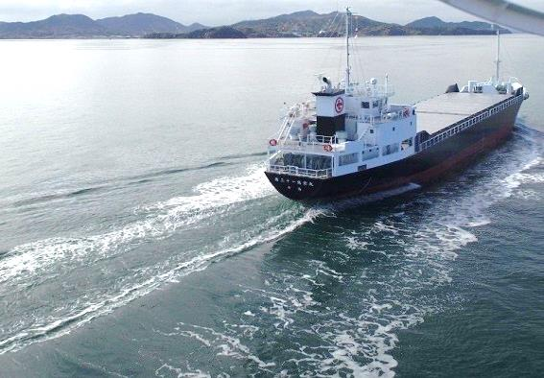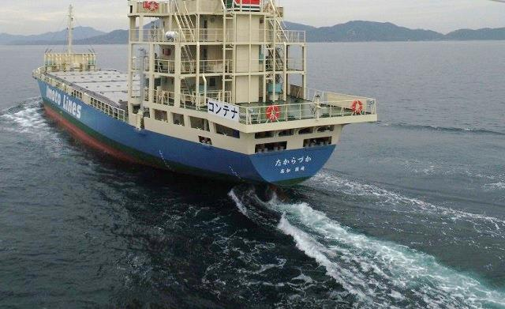In this paper, a new concept of propeller-rudder arrangement, which is called “GATE RUDDER® ” (Sasaki, Atlar and Kuribayshi 2015) is introduced. This innovative rudder system has two rudder blades with asymmetric sections which are located aside a ship’s propeller and can be controlled independently via rudder stock at the top of each blade. Owing to a duct effect of the two rudder blades, the system can achive excellent performance for not only maneuverability but also for superior propulsive performance.

Fig. 1 Wave generation by a rudder of the most up-to date container ship

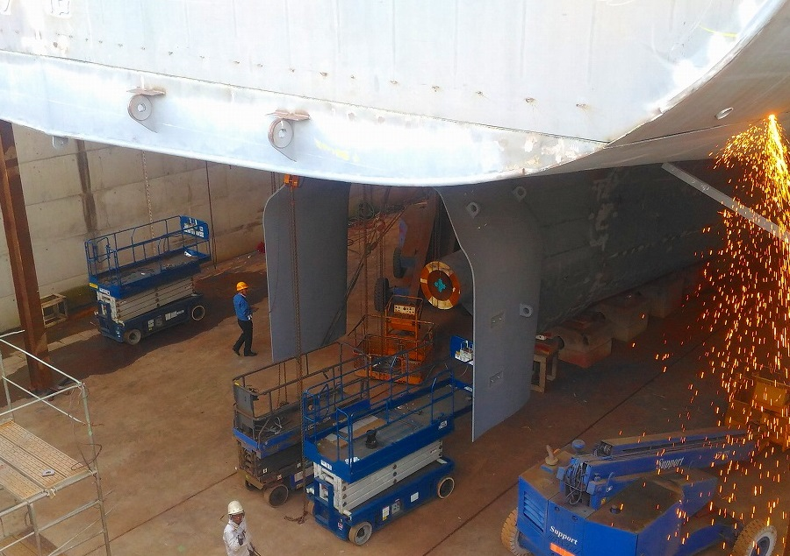

Fig. 2 Installation of GATE RUDDER® on a container ship built by Yamanaka Ship Yard

As the authors believes that the idea behind the Gate Rudder ® system is the recovery of viscous energy loss by the propulsion system, which is not well-known even to experts working in this field, in the following section of the paper this energy loss component and its recovery is explored further.

**2. Recovery of viscous energy loss**

2.1 Improvement of propulsive efficiency

It is not obvious that a ship’s propeller absorbs the waste energy caused by the hull surface and its wake which manifest itself as the viscous hull resistance (Sasaki 2011). The hull form designer therefore always tries to collect and guide the all stream lines into the propeller plane as much as possible. The viscous resistance loss is transported by each stream line as the momentum loss. If the propeller with diameteris working in the flow region exposed to this momentum loss, the propulsive efficiency increase of the vessel with speed can be estimated according to following formula:

(1)



with

(2)

Where,

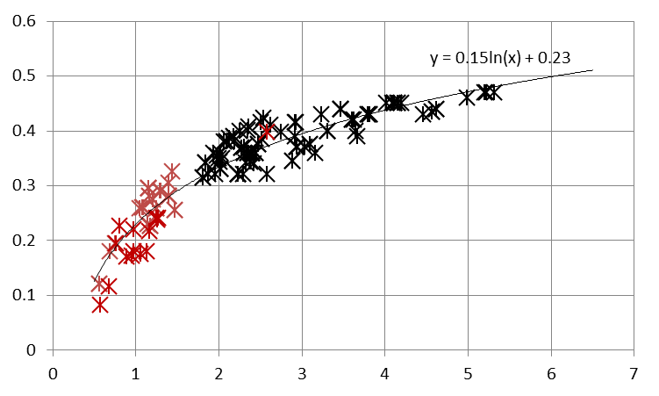is propulsive efficiency. and is wake fraction and propeller thrust loading coefficient respectively. can be calculated by equation(1) using water density and ship resistance at ship speed .The wake fraction can be divided into and which are potential part and viscous part respectively.

*w*

Fig. 3 shows the actual data of and for existing vessels. A clear relationship between two parameters can be found.

*CT*

　　　　　　　　　 Fig. 3 Relationship propeller thrust loading

and wake fraction

Fig. 4 shows the improvement of propulsive efficiency for increment of propeller diameter and wake fraction respectively.

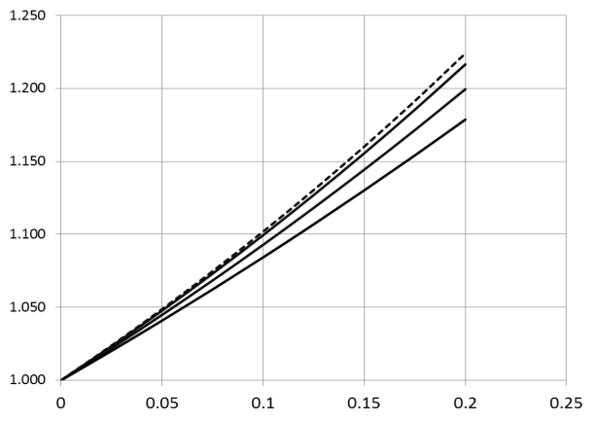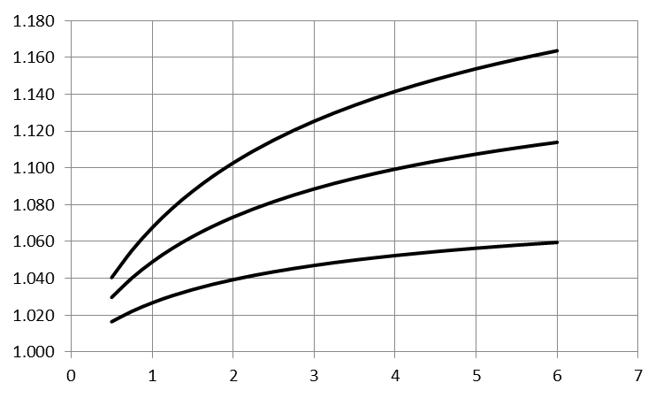

10%

20%

30%

*CT=0.5*

*CT=1.0*

*CT=1.5*

*CT=2.0*

*w*

*CT*

Fig. 4 Effect of enlarged propeller (left) and wake gain (right) on better propulsive efficiency

*CT*

30%

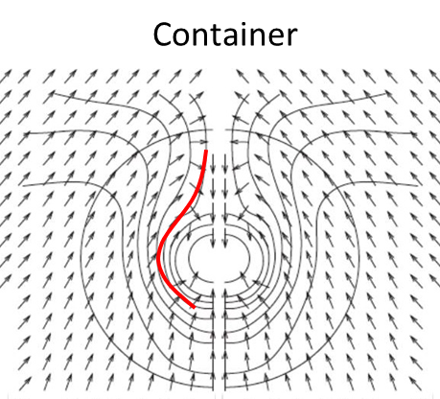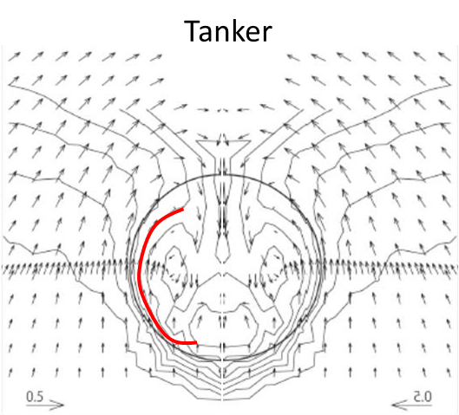

Fig. 5 Wake distribution of Tanker Fig. 6 Wake distribution of Container

Fig.5 and Fig.6 shows wake distributions on a propeller plane for a tanker and container respectively (Suzuki, Sasaki and Kawamura 2015). As we can see there are two groups of dominant wake flows. One group is a pair of wake flows at the lower part of the propeller plane while another is upper part outside of the propeller plane. The first group is formed by the bilge vortices three dimensionally separated from both bilge corners while the second group of wake is generated by the boundary layer growth on the hull surface at the upper part. .

2.2 Elementary propulsive efficiency

According to the propulsion theory, the definition of propulsive efficiency is as follows:



(3)

From the Fig.s 5 and 6, it will be a good idea to form the propulsor as large as possible to reduce the thrust density and each thrust element should be located in the lowest velocity field and far from the hull surface in x direction.

The most efficient way is to use a wing section with attack angle α and an elementary propulsive efficiency ηi can be represented as in the follows formula using this attack angleαand a local wake fraction *wi* .

(4)

$ηi=\frac{α^{2}{(1-t)(1-wi)}^{2}Sp}{DHP}πγρ{Vs}^{3}$

(5)

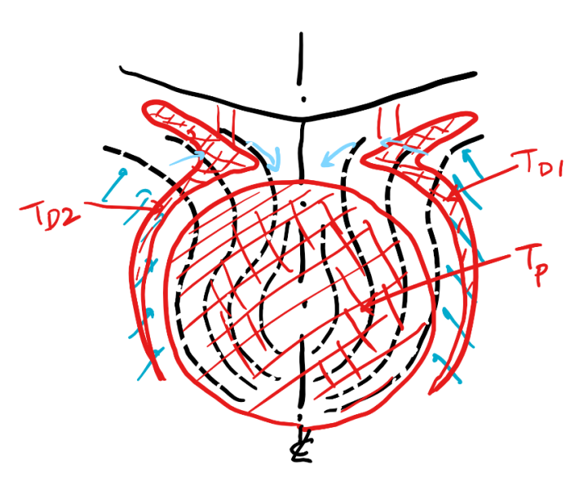

Fig. 7 Ideal shape of propulsor

with the best propulsive efficiency

where, *SP* is propeller disc area. γandρis a lift slope correction and density of the water respectively.

Fig. 7 shows an example of ideal propulsor which will give us the best propulsive efficiency for a ship if the thrust element can be established in this special form..

**3. Idea of GATE RUDDER®**

Based upon the above analogy, an extremely large square duct with a propeller was designed so as to catch both groups of the above mentioned wake flow. The difference between this ducted propeller arrangement (ie. GATE RUDDER®) and a conventional ducted propeller can be listed as follows:

1. The size of the duct is extremely large (120%-140% of a propeller diameter)
2. The duct shape is not circular like in regular ducted propeller to obtain the best elementary propulsive efficiency
3. The duct is split into two parts at the center and the each part can work as a single rudder independently
4. The bottom part of the duct was removed because the elementary propulsive efficiency is rather low

The replacement of the conventional rudder with the GATE RUDDER® can provide attractive ship stern design and easy maintenance opportunities that can be exploited in different ways as follows;

1. The overhang part of the stern which was occupied by the conventional rudder can be saved and the ship length can be shortened or.
2. The propeller can be placed further aft with the removal of the conventional rudder and the engine room can be moved wards stern which can improve the cargo capacity for the same ship length, or.
3. It is also possible to apply a better streamlined stern in front of the propeller to improve propulsive performance for the same ship length
4. The replacement of the conventional rudder with the GATE RUDDER® will provide the better access to the propeller and shafts hence easy removal of those

**4. First full scale application of GATE RUDDER® on a container ship**

4.1 General

It has been believed that the container ship is one of the most difficult vessel types which we can expect improvement in her performance by using energy saving devices (ESD). The level of energy savings has been 3-5% using existing types of ESDs because of the recovery rule which is very simple and states that we cannot recover more than energy loss we lost in the target zone. In the above case, the target zone is the propeller disc and the swirling loss of fluid due to the propeller rotation is the only source left to recover.

As discussed earlier, the duct type of energy saving devices aim to recover viscous resistance loss by collecting the streamlines distorted by hull surface with viscosity. It is well known fact that these types of energy saving devices are the most efficient compared to other ESDs. However, the duct type of ESDs have not been applied to the fine forms of ships, like container vessels, because it is hard to find distorted viscous layer near the propeller plane except the upper part far from the propeller as shown in Fig. 6.

4.2 Main particulars of the container ship

Table 1 shows the main particulars of the container ship which is fitted with the GATE RUDDER® and her sister vessel with exactly the same dimensions but fitted with a conventional flap rudder that was delivered one year before. It was therefore thought to be a good idea to compare these two vessels not only based on the sea trial results but also based on their voyage data selecting the same route and period.

Table 1 Principal dimensions of two sister ships with different rudders

|  |  |  |
| --- | --- | --- |
|  | **Ship A (Flap Rudder)** | **Ship B (GATE RUDDER® )** |
| Loa (m) | 111.4 | 111.4 |
| Lpp (m) | 101.9 | 101.9 |
| B (m) | 17.8 | 17.8 |
| D (m) | 8.5 | 8.5 |
| d (m) | 5.24 | 5.25 |
| Main Engine | 3309kW/220rpm | 3309kW/220rpm |
| Prop. Dia　(m) | 3.48(CPP) | 3.30(CPP) |
| Rudder Type | Flap rudder | GATE RUDDER® |
| Draft of Sea Trial (m) | 4.30 | 4.30 |
| Date of Sea Trial | 27-28th July 2016 | 15-16th Nov.2017 |

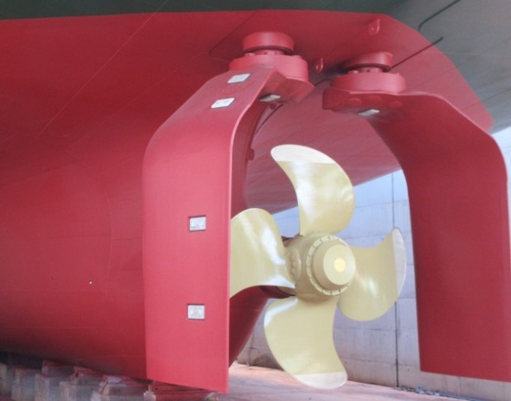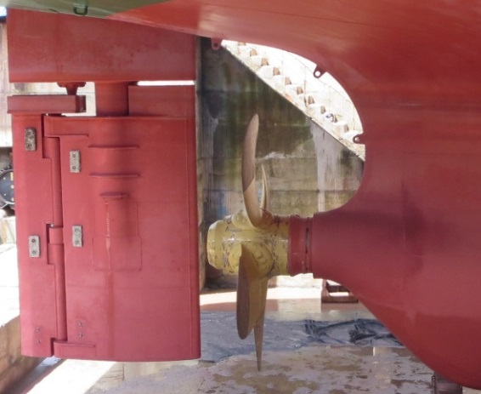

Fig. 8 Flap Rudder (Ship A) and GATE RUDDER® (Ship B)

4.3 Speed Trial

The sea trials were conducted at Seto-uchi Sea according to a standard procedure based on the double run and the same direction and same position as shown in Fig. 9. The speed trial of ship A (Flap Rudder) and ship B (GATE RUDDER® ) was conducted 27th July. 2016 and 16th Nov.2017 respectively. The test conditions of both vessels were exactly the same as shown in Table 1. Fig.10 shows the weather conditions of the two vessels. The weather condition of ship B (GATE RUDDER® ) was rather worse compared with the weather condition of ship A (Flap Rudder) as can be seen from Fig. 10. It was concluded that the measured data should be corrected by taking the wind and wave effect into account addition to the correction of current.

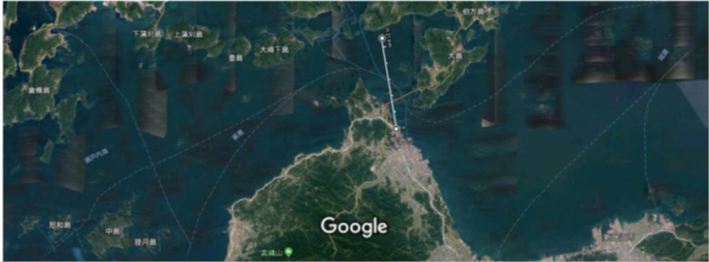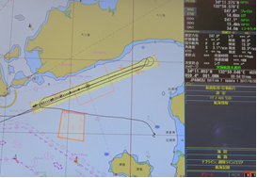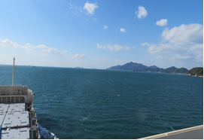

Fig. 9 Speed Trial Site and Weather Observatory Point of Japan Meteorological Agency)

The speed trials for both vessels were conducted at the same place with the same procedure. The wind velocity was measured by the instruments at the bridge. The measured data was examined by the official weather records of 11miles away point measured by JMA (Japan Meteorological Agency). Fig. 10 shows the comparison of two data. The measured data seems reasonable as the data is very close to JMA mean data. The wave height was decided based on eye sight judgement and video films were used for the evaluation purpose by an expert afterwards

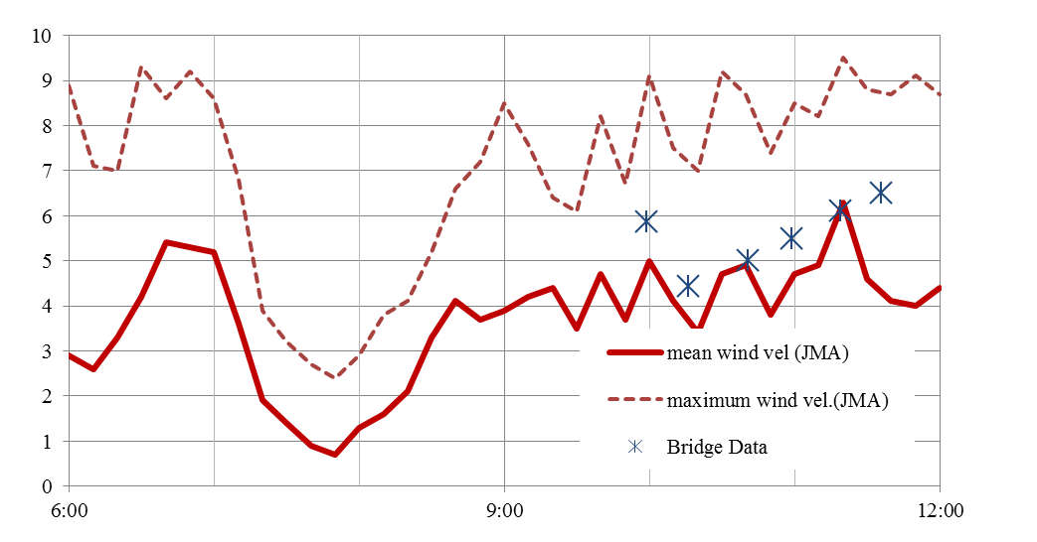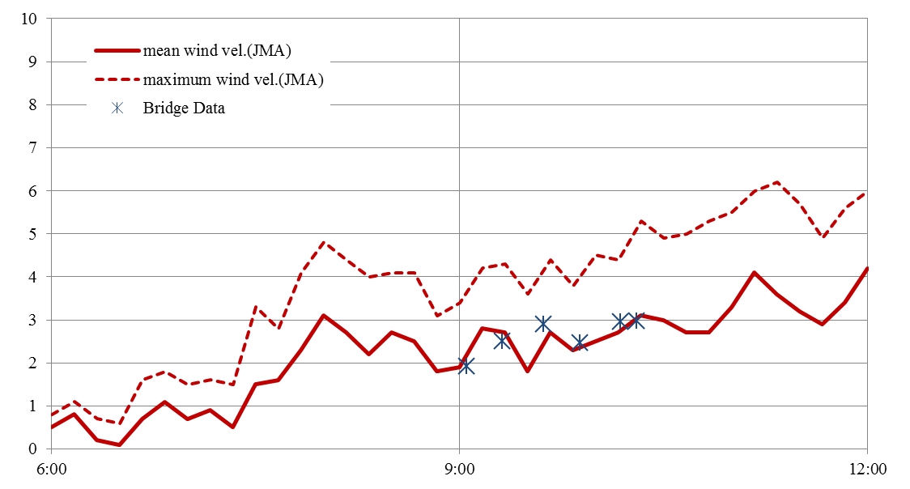

Fig. 10 Wind force records for Ship A (left) and Ship B (right)

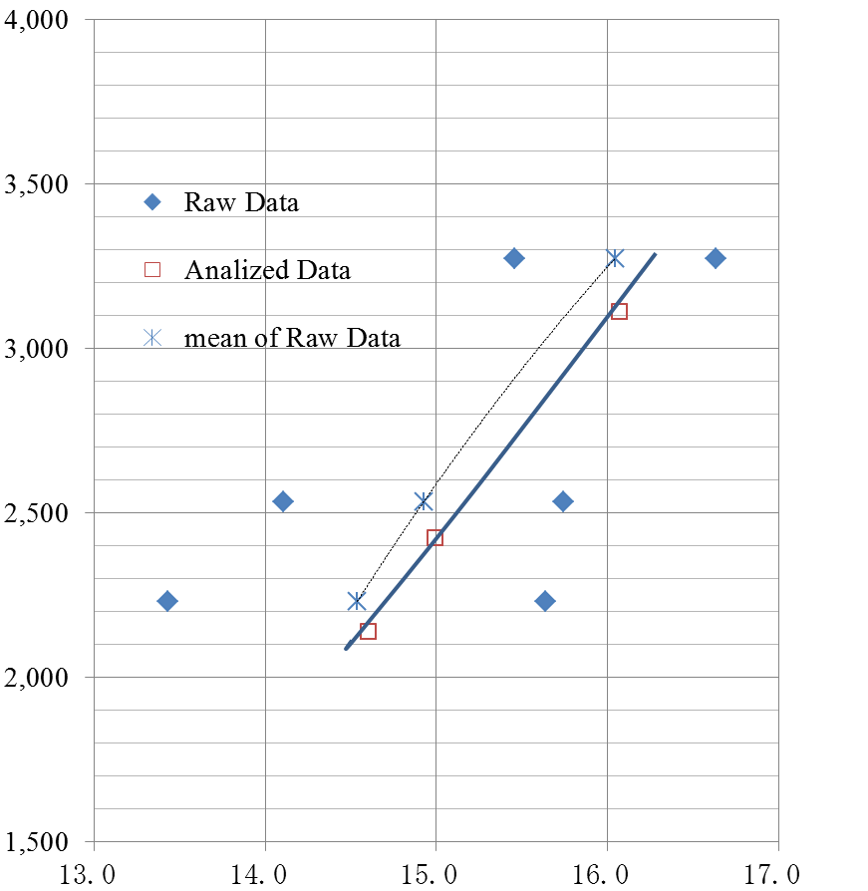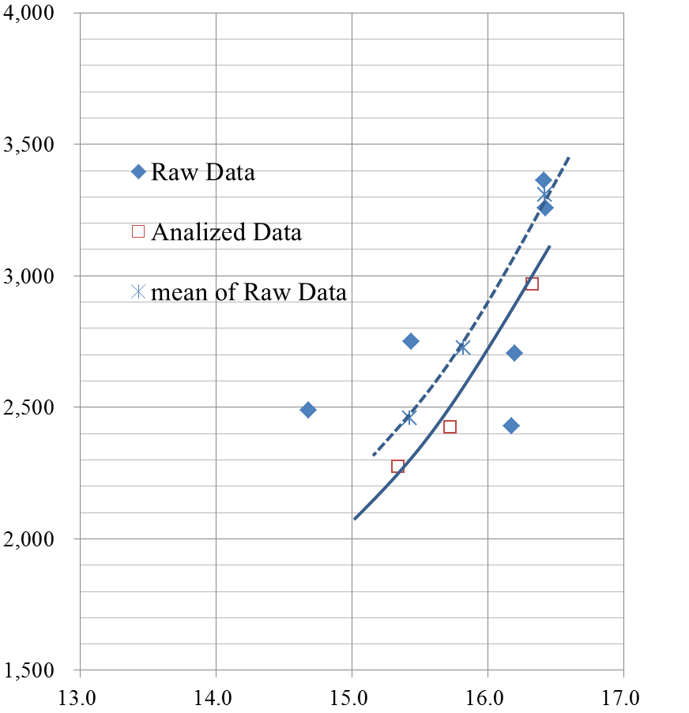

Ship A

Ship B

Fig. 11 Speed trial results of Ship A (Flap Rudder) and Ship B (GATE RUDDER® )

Table 2 shows the measured power in kW at 15.5 kts for both raw data and analyzed data. From this table it was concluded that the power saving of GATE RUDDER® is around 14%.

The engine performance data of two vessels were examined and it was confirmed that the two engines were showing almost the same SFC. It is well known fact that the measured power at sea trial could be very low if the measured engine performance (SFC) was very bad. For the ship owner, the relationship between fuel consumption and ship speed is more important than relationship between power and ship speed.

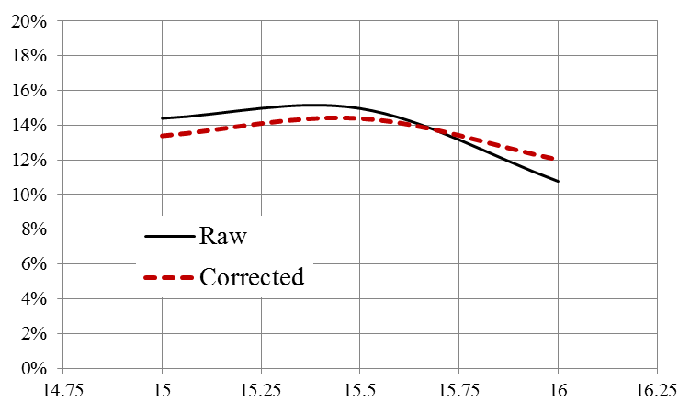Table 2 Measured powers (kW) obtained from speed trials

(raw data and corrected data)



Fig. 12 Power saving by GATE RUDDER®

obtained from speed trial data

As the domestic vessels have the same feature which is ship/engine size and propeller rudder configuration, it seems that the obtained power saving can be applied to all existing vessels.　Based on this assumption, Fig. 13 is presented to show the impact of the GATE RUDDER® on the environmental from the GHG emission point of view and on the economical market of domestic vessels.

After delivery of ship B (GATE RUDDER® ), the monitoring has been continuing and further data will be presented at the conference.

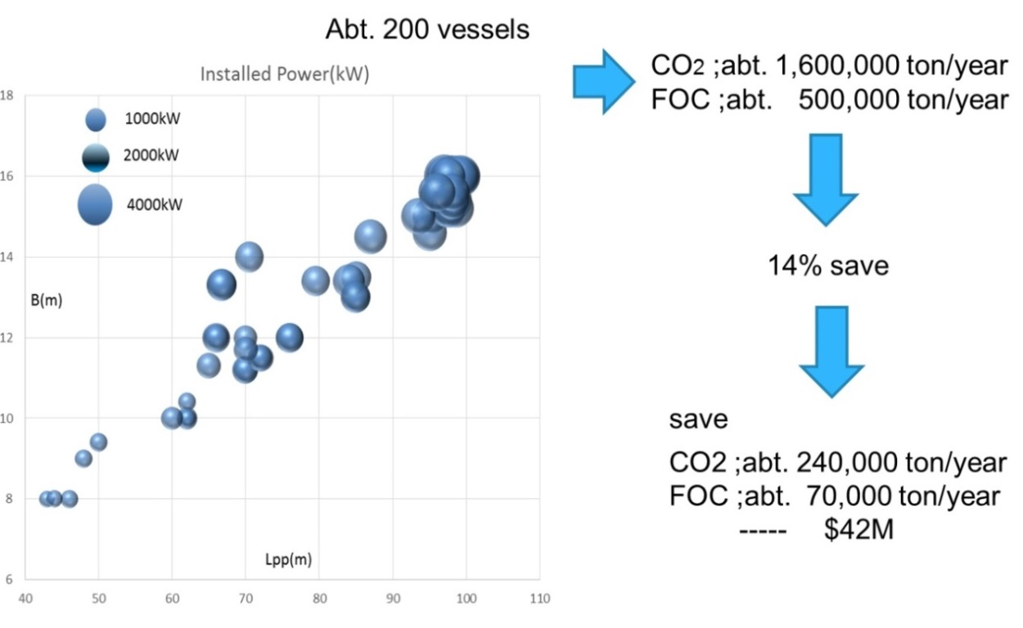

Fig. 13 Environmental and economic impact of GATE RUDDER®

on market of domestic vessels

4.4 Maneuvering

In order to predict the motion of the ship with GATE RUDDER® , several model tests were conducted. Based on these model test data, a maneuvering simulation program for a ship with GATE RUDDER® was developed based on the studies conducted by Newcastle University and Kamome Propeller (Carchen, Shi . and Sasaki 2017).

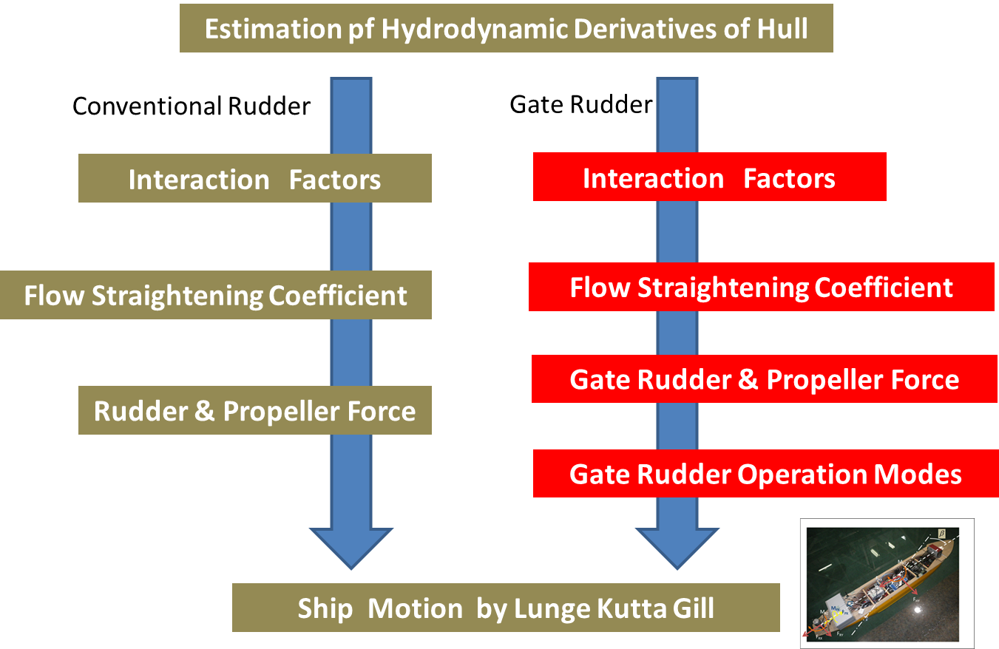

Fig. 14 Simulation flow of maneuvering motion of a ship with GATE RUDDER®

Modified MMG model was used for the prediction of a ship motion with GATE RUDDER® as shown in Fig. 14.

Major modification is the rudder force of the GATE RUDDER® which varies depending on the rudder position around the propeller. Axial velocity *uR* and lateral velocity *vR* are investigated not only captive model tests, but also CFD calculations and;

following new equations are introduced;

 for the area behind the propeller

-0.0015 for the area outside of the propeller slip stream

(6)

for port side rudder

for starboard side rudder

Here, rudder angles and yaw angles  is given by next Fig. in degree.

In order to predict the rudder force under the condition of partially covered by the propeller slip stream, following new equations were introduced;

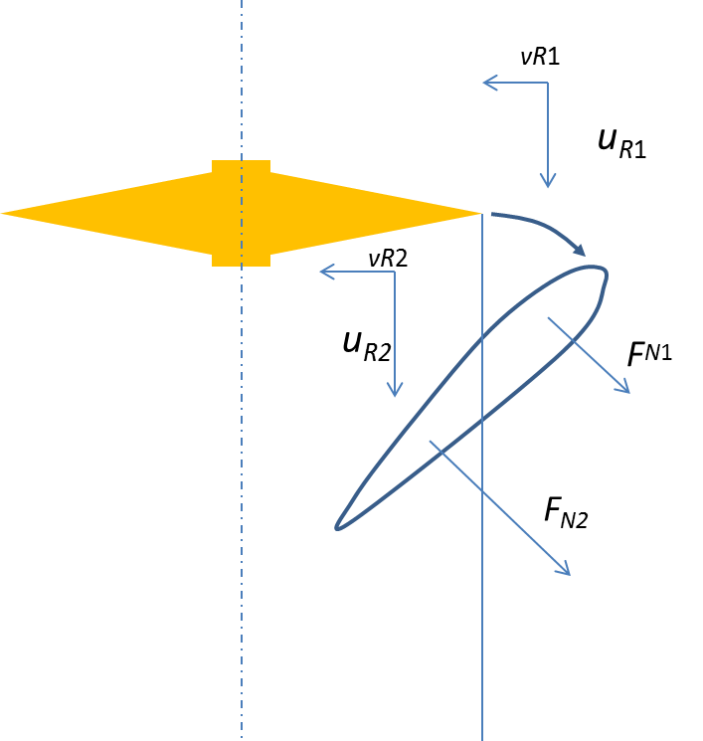

(7)



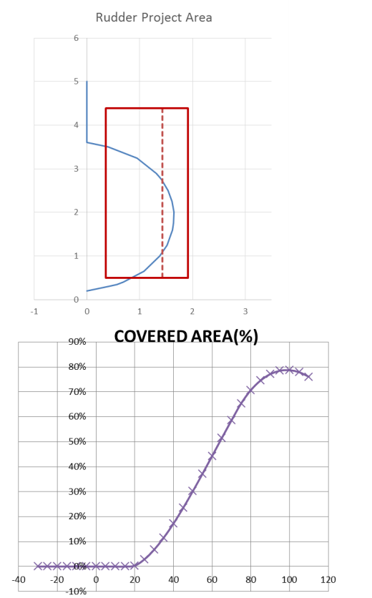

*ACV*





where *FN*is rudder normal force and *CL* is lift coefficient.



(8)

Where, *LLE* and *LTE* is project length of leading edge and trailing edge of the rudder blade respectively. *R* and *E* is transverse distance from the ship center line of rudder trailing edge and rudder leading edge respectively.

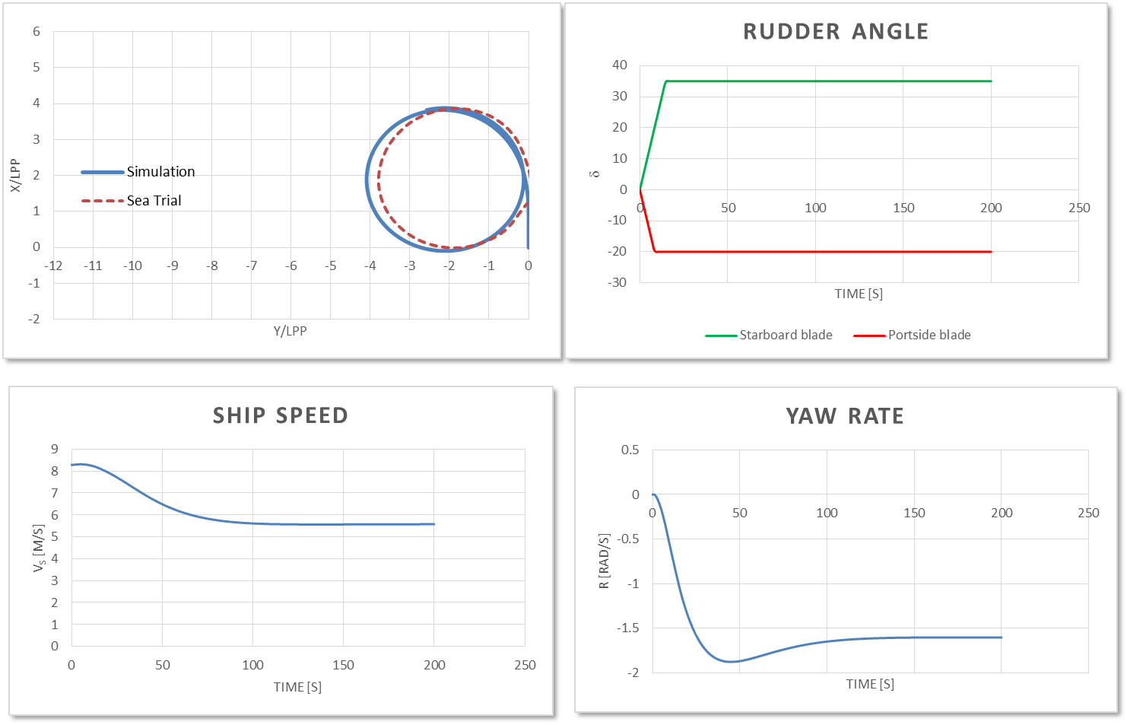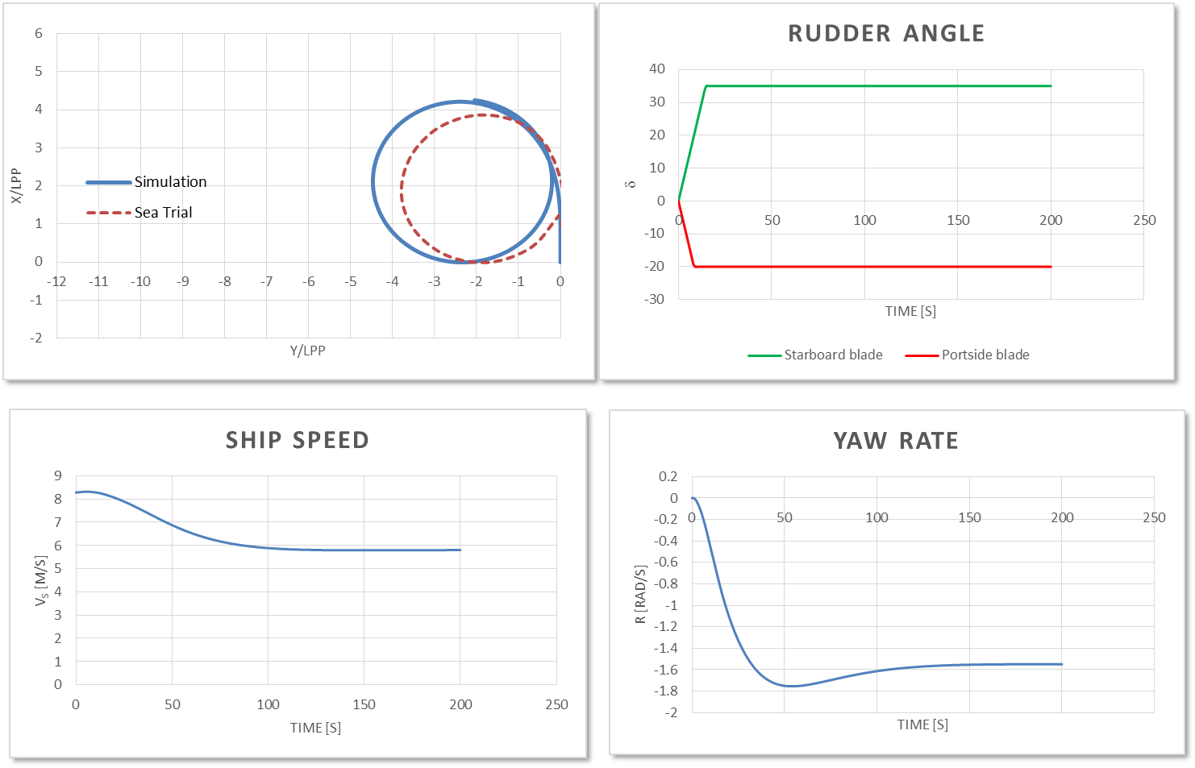

Fig. 15 Example of simulation results for steady turning (Model Scale)

Fig. 16 Example of simulation results for steady turning (Full Scale)

Fig. 15 and Fig. 16 shows the simulation results of 35 deg. circle test for a model scale and a full scale respectively. Based on the captive test of a 2.5m similar model, the simulation program was developed, however, the full scale flow field of GATE RUDDER® is quite different from the model ship because the flow surrounding the GATE RUDDER is almost outside of the boundary layer while the flow field of the conventional rudder is still inside. According to the paper presented by Kuribayashi (Kuribayshi et.al. 2015) , rudder force can be modified in order to predict full scale maneuverability. The difference can be seen from Fig. 15 and Fig. 16.

The full scale sea trial for the spiral test was conducted on 14th November prior to the official sea trial and the result is shown in Fig. 17 with the simulation result which is explained in the above.

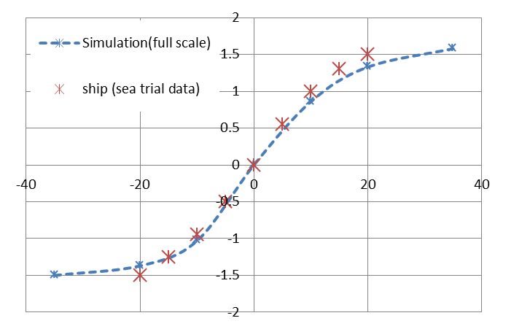

**r’ (deg./sec)**

**Rudder Angle (deg.)**

Fig. 17 Result of full scale spiral test and simulation results

The GATE RUDDER® has very high lift to drag ratio compared with a conventional high lift rudder as shown in Fig. 18. The drag of the GATE RUDDER® is lower than 50% of the conventional high lift rudder and this remarkable feature favors following advantages for the GATE RUDDER® ;

1. Speed drop due to helm is very small and this will contribute not only energy saving but also safety in the stormy condition because the ship without enough speed will bring risks of controlling of the ship by a rudder.
2. Circular motion is very quick and steady

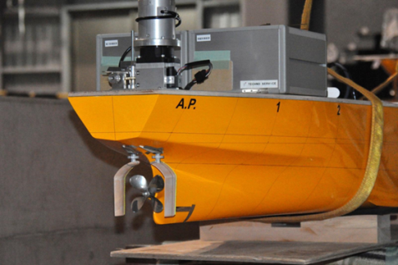

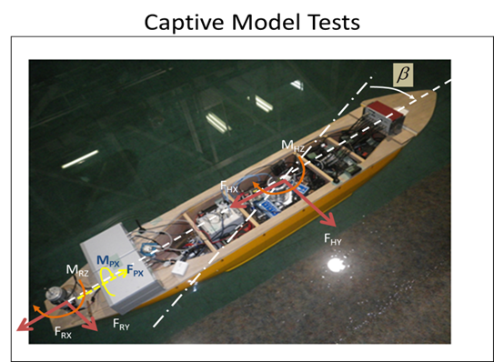

Fig. 18 Captive model test at Kyusyu University

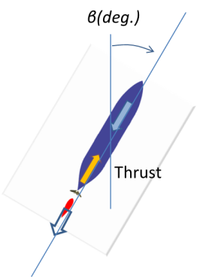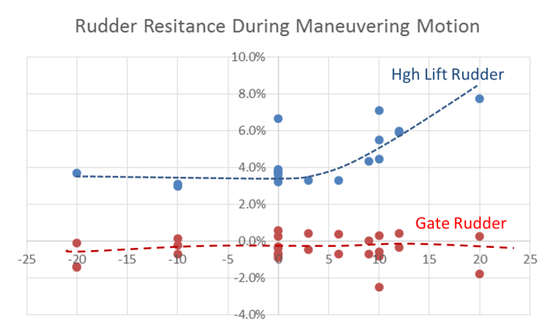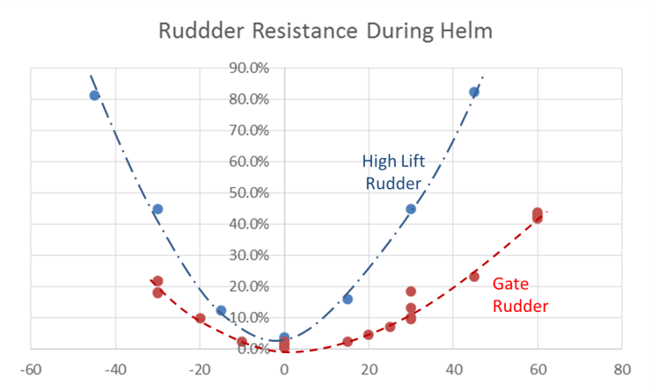

δ(deg.)

δ

β

Fig. 19 Variation of rudder resistance (% of Thrust) due to maneuvering motion

0 KTS

9 KTS

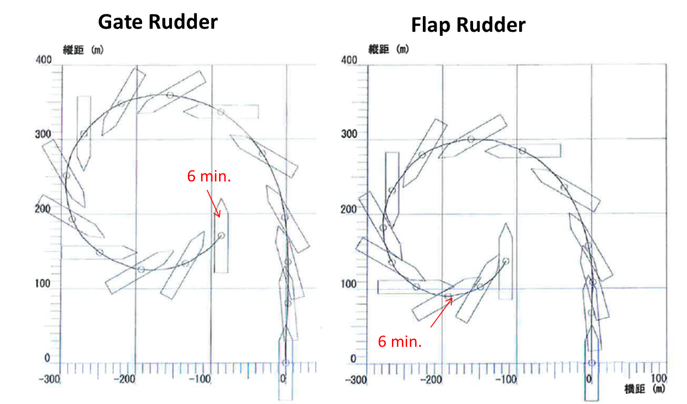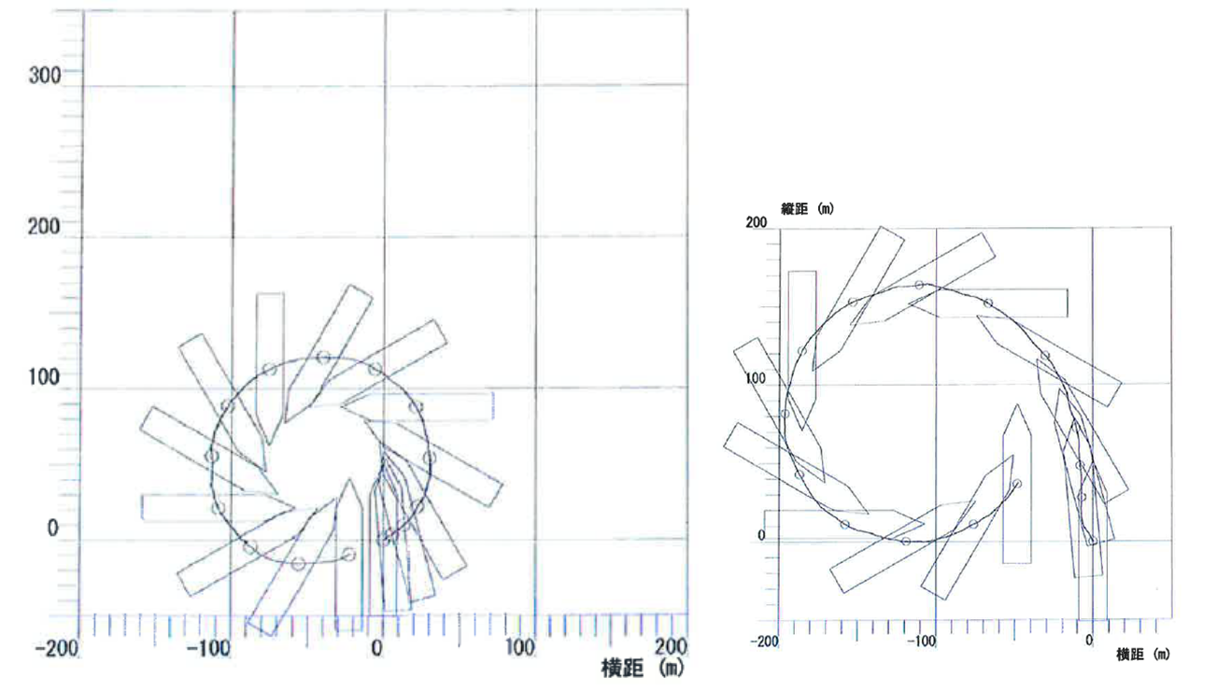

**Gate Rudder**

**Flap Rudder**

Fig. 20 Full scale 35deg Circle Test (Low Speed and Zero Speed)

for Ship A (Flap Rudder) and Ship B (GATE RUDDER® )

The maneuvering test was conducted using two days and summarized in the Table 3.

Table 3 Summary of Steering and Maneuvering Tests

|  |  |  |  |  |
| --- | --- | --- | --- | --- |
|  |  | Portside | Starboard | mean |
| Circle (35deg.)  Vs0=16.1kt | Tactical Dia./L | 3.19 | 3.26 | 3.23 |
| Advance/L | 3.85 | 3.55 | 3.70 |
| Circle (70deg)  Vs0=9kts | Tactical Dia./L | 2.69 | 2.59 | 2.65 |
| Advance/L | 3.35 | 3.40 | 3.38 |
| Stopping Distance/L | 15.3kts->0kts | - | - | 6.7 |
| 0kts ->16.1 | - | - | 16.3 |
| 10 Z maneuver  (O.S.A in deg.) | 1 st OSA | 11.1 | 11.1 | 11.1 |
| 2nd OSA | 26.7 | 26.6 | 26.7 |
| Crabbing | Tactical Dia./L | 0.75 | 0.47 | 0.61 |
| Advance/L | 0.87 | 0.52 | 0.69 |

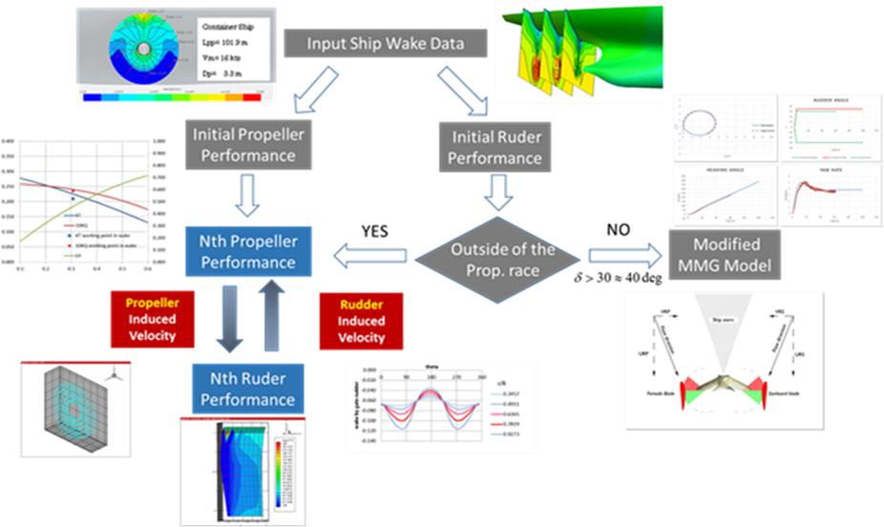Fig. 21 Systematic design flow of GATE RUDDER®

based on VLM, SPT and modified MMG

In conclusion, the ship has a both superior turning and course keeping ability. The response of the rudder is very smooth as we can see the result of spiral test shown in Fig. 16.

The rudder blades have a camber and attack angle even at the position of zero helm angle due to the interaction between the rudder blade and propeller. The interaction model based on the simplified propeller theory (Yamasaki,1962, Nakatake 1981) and vortex lattice method (Lan 1974)was established as shown in Fig. 22.

Load distribution on the rudder blades is important to calculate the stress due to forces and moment and stress by FEM. Fig. 22 shows the example of the load distributions for the helm angles at zero degree (left) and 25 deg.(right). The load distributions are viewed from inside and the blue and red color means suction force and pressure force respectively. The force towards inside (ship center line) can be seen when the rudder angle is zero. This is mainly due to propeller induced velocity calculated by the simplified propeller theory.

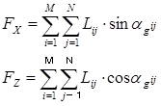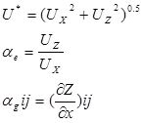

(9)



where,

*F* and *L* is Total force acting on the rudder blade and lift force distributed on the surface of the rudder respectively. Lift force *L* can be calculated by using circulation *Γ* , velocity U and flow angle α. The suffix x ,y and z represents its direction x, y and z respectively. The suffix ij means the panel number which arranged by m-row and n-column..



Fig. 22 Load distributions on the ruder surface (camber surface) calculated by VLM

**5. Concluding remarks and future work**

* The analyzed data for both sea trial and voyage data indicate abt. 14% of fuel saving for the vessel fitted with GATE RUDDER® over her sister ship. This is very attractive to ship owners and shipbuilding companies. The predicted energy saving was 8-10% from the study of the model test and CFD, while the full scale data revealed a remarkable saving 14%. The discrepancy is still very large and this should be investigated with further research which should concentrate not only on the steady state conditions but also on the actual sea conditions where the ship needs small helm to keep the course.
* 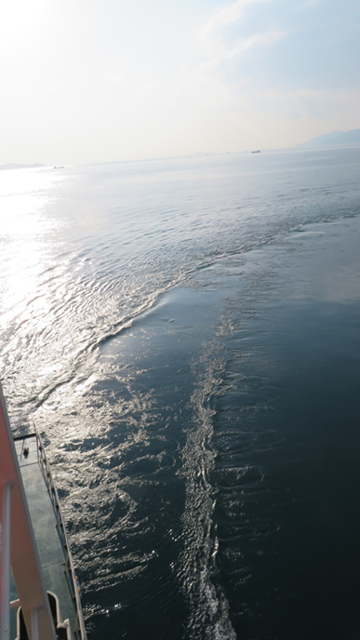The above research should be supported by the continuous analysis of the voyage data. The on-board monitoring plan therefore has been decided to measure the shaft power by torque meter and the effect of wind wave by using onboard equipment as well as the other available data. A dedicated engineer on-boards the container vessel will be coordinating this equipment support action..
* During the full-scale trials extremely low wake wash of the vessel with the GATE RUDDER ® was noted by observations as well as from the video records (see Fig 23). This will require further investigations for the effect of the new rudder system on the stern wave characteristics.

Fig. 23 Low wake wash of GATE RUDDER®

* Finally, the computer simulations and model tests indicated the drag characteristics of the GATE RUDDER ® during the maneuvering motion are rather different from those of the conventional rudders and the magnitude of the drag of GATE RUDDER® is less than 1/4 of flap rudder.. This feature will make a ship safer in the heavy sea conditions such as Beaufort Scale 7 and the GATE RUDDER® will be assisting the propeller by producing the additional thrust. On this basis it will be very interesting to compare the ship motions of the same vessel with different rudder configurations (conventional rudder vs GATE RUDDER ®) to take advantage of the motion control by using the GATE RUDDER ® more effectively.

References

1. Carlton J ,“Marine propeller and propulsion” 3rd Edition 2012
2. Sasaki N, Atlar M and Kuribayshi S, “ Advantage of twin rudder system with asymmetric wing section aside a propeller” Journal of Marine Science and Technology ,2015
3. Sasaki N., “ ZEUS project of NMRI”, 1st World NAOE Forum, 25 November 2011, Osaka, Japan
4. Suzuki K.,Sasaki N, Kawamura T., “Resistance and propulsion” to be published by Seizando Shoten Publishing Co

5) Turkmen S, Carchen A., Sasaki N., Atlar M.” Anew energy saving twin ruder system”, International Conference on Shipping in Changing Climates”, Nov. 2015, Glasgow

6) Turkmen S., Sasaki N., Miles A., “The GATE RUDDER application to a ship with poor course keeping ability” 1st International Meeting on Propeller Noise and Vibration, November 2014, Istanbul

7) Yasukawa S.,Yoshimura Y., “Introduction of MMG standard method for ship maneuvering predictions” Journal of Marine Science Technology, 2015

8) Kuribayashi S. et.al., “The new hull form with twin rudders utilizing duct effects”, Journal of JASNAOE, May, 2016

9) Charchen A., W. Shi, Sasaki N. “ Gate Rudder maneuverability simulator”, Project Report of Newcastle University, 2017

10) Yamazaki R., “ On the theory of screw propellers, Proc. Symposium Nav. Hydro., 1962

11) Nakatake K., “ Application method to calculate propulsive performance of ships”, memories of the Faculty of Engineering Kyusyu University vol41, 1981

12) Lan C.E., “ A quasi-vortex lattice method in thin wing theory”, Journal of Aircraft vol.11, 1974